**Quantitative Trait Loci Mapping in chicken (*Gallus gallus* x *Gallus gallus domesticus*)**

**Results**

Firstly, we detected the missing genotypes (figure 1); subsequently, we rearranged the plot according to the value of the individual’s phenotype. Most of the markers were genotyped for most individuals. The missing rate was low (3.7%).

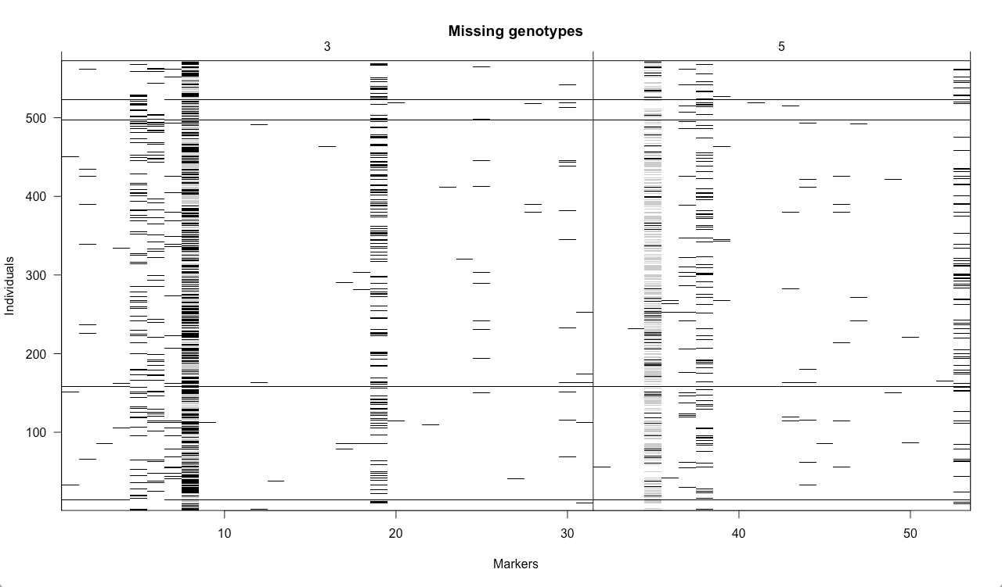

Figure 1: Genotyped markers for every individual of the population. White indicates available genotype, black indicates missing genotype

The body weight in this population seemed to follow a normal distribution. The individuals differed highly, so the body weight was added into the analysis as a covariate.

Additionally, a plot of the comb weight showed that there were differences in comb weight and in its frequency between sexes (figure 2). Within the sexes the comb weight was normally distributed.

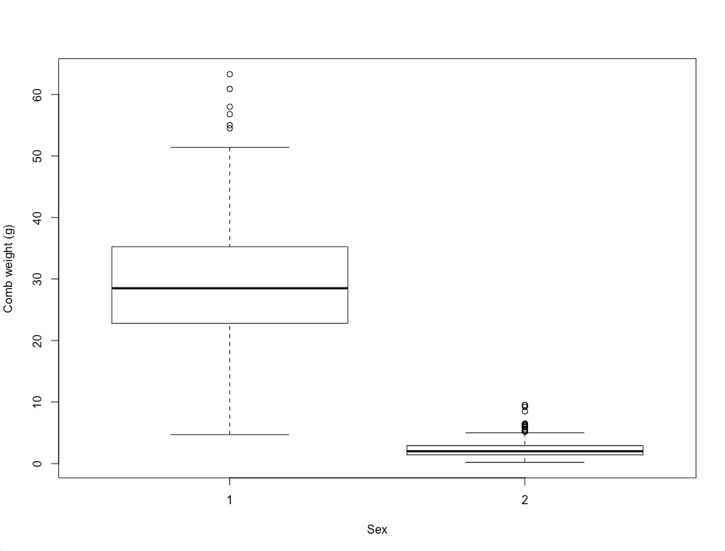

Figure 2: Distribution of the comb weight in males (1) and females (2)

We used the Lander-Green algorithm in R to estimate the genetic map (figure 3). All the markers were located on chromosome 3 and chromosome 5. The maximum genetic distance between neighboured markers was 2 cM. As we had some genotype information for all the markers we did not delete any.

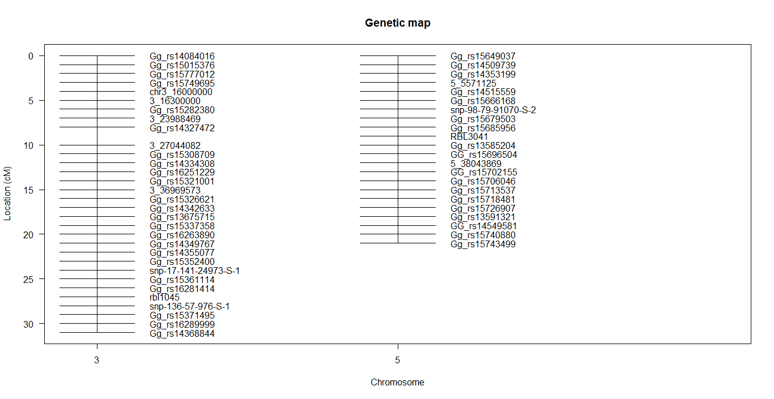

Figure 3: Genetic map with the label of the markers and their positions in the chromosomes 3 and 5

We continued by analysing the pairwise recombination fractions and the logarithm of odds (LOD) scores of our data, looking for abnormalities (figure 4). We found that the marker 7 in the chromosome 3 and the marker 34 in the chromosome 5 showed a very low recombination rate. We expected this recombination rate to be higher, since these two markers were located in two different chromosomes. Furthermore, marker 3 on chromosome 3 had a high recombination rate with its neighbours.

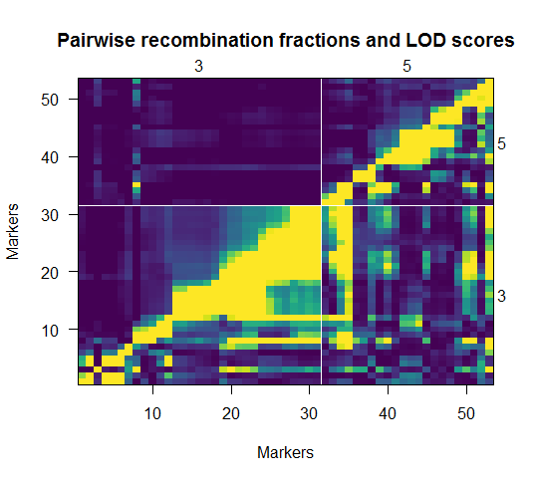

Figure 4: Pairwise recombinations and LOD scores for the markers in the chromosomes 3 and chromosome 5; red frames indicate recombination abnormalities

Afterwards, we calculated a new genetic map using the recombination scores. Although the new map showed that most of the markers were homogeneously distributed in the chromosomes, there was one marker in chromosome 3 with a distance of 1000 cM to its neighbouring markers. We did not expect this distance, so we continued our analysis by looking for genotyping errors. We found a possible genotyping error in the third marker on chromosome 3 (Gg_rs15777012). Based on this, we considered that this marker was not well genotyped and the distances could not be estimated properly, thus we deleted it. The markers on the chromosome 5 showed none of these problematics so we kept them all. Afterwards we calculated a new genetic map, shown in figure 5.

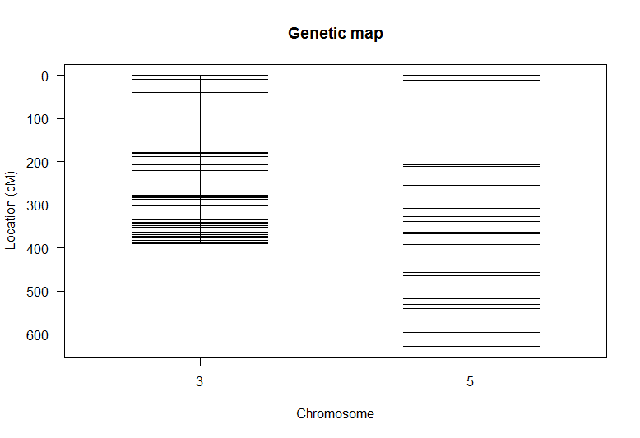

Figure 5: New genetic map after deleting the marker Gg_rs15777012

We then continued with the quantitative trait loci (QTL) analysis. First we assessed whether sex and weight influenced comb weight (Pearson correlation weight *vs* comb weight; r=0.739, p-value <0.001, t-test comb weight *vs* sex; t=38.176, p-value < 0.001). As it can be seen for the results of the Pearson correlation and the t-test, these two factors (sex and weight) affected the comb weight. Therefore, we combined these data in one single vector and added it to the model as a covariate.

In order to detect possible QTL candidates, we first performed a single QTL genome scan. To verify our results we applied three different methods, as shown in figure 6 (EM algorithm (black), Haley-Knott regression (blue) and multiple imputation method of Sen and Churchill (red)). All three methods accomplished similar results: they indicated two high LOD scores, corresponding to the markers Gg_rs15749695 (chr. 3) and c5.loc360 (chr. 5), that exceeded the threshold set at 3.08 by the permutation test (LOD scores: 21.45 and 5.84, respectively). The similarity of all methods allowed us the assumption of detecting QTLs at these chromosome positions. We could ignore the additional peak of the EM algorithm because it was likely to be caused by a lack of markers in this area.

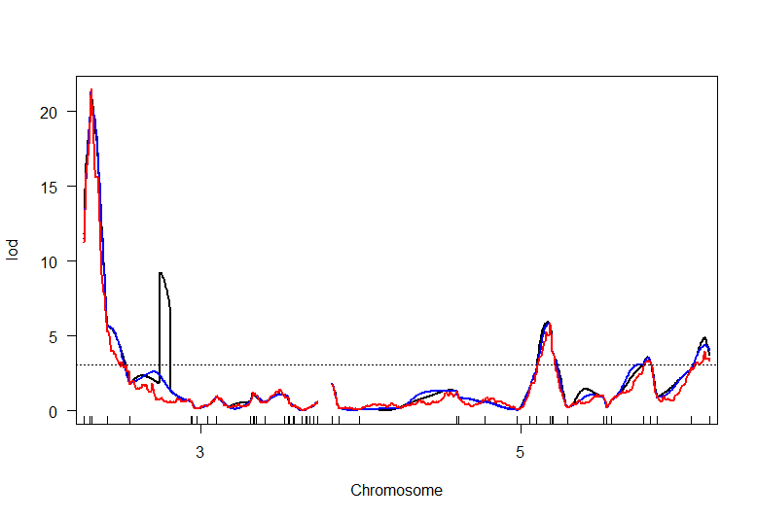

Figure 6: Single QTL genome scan using the EM algorithm (black), Haley-Knott regression (blue) and multiple imputation method of Sen and Churchill (red) for chromosome 3 and 5.

A threshold was set at a LOD score of 3.08

Table 1 showed the estimated additive and dominant genetic effects of the QTLs at the two positions and their interaction within different genotypes (table 1 + figure 7). The comb weight depended on the combination of the genotypes in QTL 1 and QTL 2.

Table 1. Estimated additive (a) and dominance (d) effects of the QTLs (chromosome:position) given with standard error (SE) and t-value for significance

|  |  |  |  |
| --- | --- | --- | --- |
|  | Estimate | SE | t |
| Intercept | 14.7781 | 0.6996 | 21.122 |
| a 3:15.8 | 4.0848 | 0.9936 | 4.111 |
| d 3:15.8 | -2.2537 | 1.4016 | -1.608 |
| a 5:361.0 | -1.0385 | 1.0188 | -1.019 |
| d 5:361.0 | -3.0465 | 1.4539 | -2.095 |

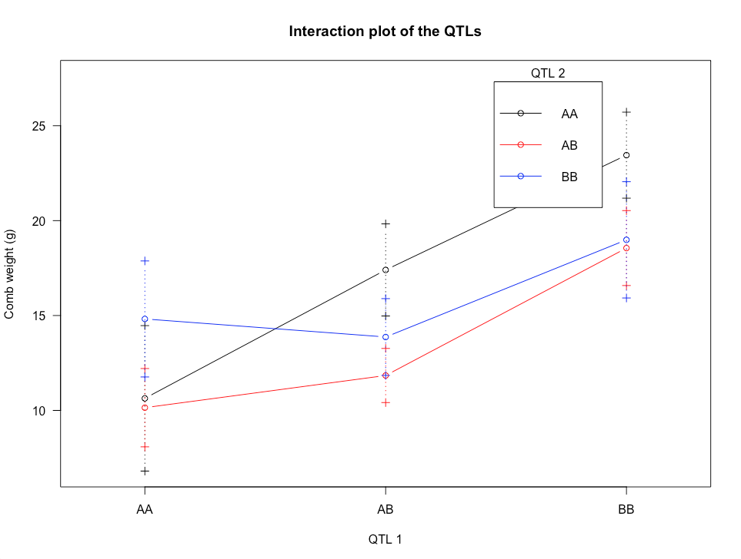

Figure 7: Influence of the interaction of the additive and dominance effects of the two QTLs on the comb weight; A and B indicate the parental lineage

Finally, we estimated these QTLs in the context of a multiple-QTL model. We tested the QTLs independently and combined. The model showed a high significance (p-value <0.001). The positions of the QTLs changed from 15.8 cM to 15.763 cM in chromosome 3 and 361.0 cM to 445.0 cM in chromosome 5. We accepted these two positions as QTLs influencing the comb weight. Figure 8 showed the final genetic map indicating the positions of the two QTLs.

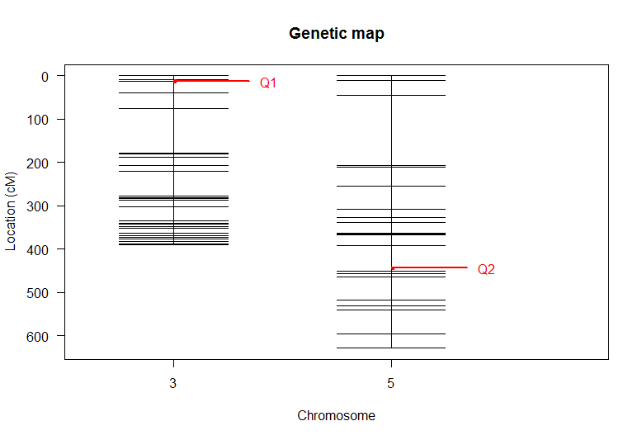

Figure 8: Genetic map with the positions of the found QTLs in each chromosome, indicated with red arrows

**Discussion**

Based on our results, we could conclude that there were two QTLs, one in chromosome 3 and one in chromosome 5 that influenced the comb weight in these chicken. The changes we found in comb weight were purely genetic, since sex and body weight were added as covariates into the analysis. The QTL located at 15.763 cM (chromosome 3) had a higher LOD score and thus was more likely to have a higher influence than the QTL located at 445.0 cM (chromosome 5).

Nevertheless, further studies are needed to investigate how and how many genes in those regions contribute to the comb weight. For instance, an eQTL mapping could be performed to detect which genes are more expressed and therefore have a bigger influence on the phenotype of interest. A knockout experiment of identified genes in one or both of the QTLs could be performed to investigate the role of the QTLs.